Emergency Communications Sub-Plan

## Version Control

The Latrobe City Municipal Emergency Management Communication Plan is a sub plan of the Municipal Emergency Management Plan. Major changes to the Communications Plan must be approved and authorised by the Municipal Emergency Management Planning Committee (MEMPC).

This document will be reviewed by the Communications Sub Committee annually or after an event. Any changes to the document will be forwarded to the MEMPC for adoption.

The record below is to be completed by the person making the amendment(s). Each new page will have a revision number and date of issue printed on it.

|  |  |  |  |  |
| --- | --- | --- | --- | --- |
| Version | Page Number | Date | Description | Amended by |
| Draft Version 1 | All | May 2015 | Plan developed | Communications Sub Committee |
| Plan adopted by MEMPC | All | 7 August 2015 | Plan Adopted | MEMPC |
| Plan adopted by MEMPC | All | 6 March 2018 | Plan Adopted | MEMPC |
|  |  |  |  |  |
|  |  |  |  |  |

**Disclaimer**: This work has been compiled from a variety of sources including material generally available on the public record, reputable specialist sources and original material. Care has been taken to verify accuracy and reliability wherever possible. However, the material does not provide professional advice. Latrobe City Council does not give any warranty or accept any liability concerning the contents of this work.

Contents

Version Control 1

Introduction 3

Aim 3

Objectives 3

Background 4

Part One - Communications External 5

Part Two - Telephone Communications 6

Part Three - Communication Resources 7

Part Four - Public Information and Warning 8

Part Five - Prevention and Preparedness 9

Part Six - Response Phase 10

Part Seven – Relief and Recovery Process 11

7.1 Information Management Principles 12

7.2 Community Engagement and Communication Strategy 12

7.3 Community Briefings 13

7.4 Development and Use of Community Networks 13

Part Eight - Information Management 15

Part Nine - Media 16

Part Ten - Dissemination 17

Part Eleven - Communication Methods 18

Part Twelve- Information Resources 19

Part Thirteen - Warning Systems 20

Part Fourteen - Emergency Communication Systems 23

Part Fifteen - Geographic 25

Part Sixteen - MECC Communications 26

Part Seventeen - MECC Internal and External Communications 27

Part Eighteen - Latrobe City Internal Emergency Communications Procedure 29

Part Nineteen - Appendix: 30

## 

## Introduction

This plan, has been developed by the Latrobe City Emergency Communications Sub-Committee is designed to meet the needs of Latrobe City Council and the Municipal Emergency Management Planning Committee, whilst at the same time provide an operational resource for communications issues during all types of emergencies within and across Municipal boundaries.

## Aim

To provide effective communications during all phases of Emergency Management across all agencies and the community, both internally and externally.

## Objectives

The broad objectives of this plan are to:

* Implement communication measures to assist with the prevention or reduction of the causes or effects of emergencies
* Assist with management arrangements for the utilisation and implementation of municipal resources in providing relief and response to emergencies.
* Assist with the management of support that may be provided to or from adjoining municipalities.
* Assist the affected community to recover following an emergency by providing an effective communication strategy.
* Complement other local, regional and state planning arrangements.
* As identified and consistent with the Municipal Emergency Management Plan (MEMP)

## 

## Background

The *Emergency Management Manual Victoria (EMMV),* Part 7, specifies agency roles and in regards to communications, and nominates the following agencies to undertake the tasks listed:-

Latrobe City Shire Council

* Facilitate the delivery of warnings to the community.
* Provision of information to public and media.

Latrobe City will also provide information services to affected communities, using e.g. information lines, newsletters, community meetings and websites where appropriate.

Telstra –

* Provide products and solutions with the ability to communicate effectively with emergency response teams, groups of volunteers, media and the whole community.
* Ensure supporting emergency communications facilities are provided to response agencies and the community.

Victoria Police

* Responsible for the provision of media coordination (where no other facility exists).
* Activation of WICEN

Wireless Institute Civil Emergency Network (WICEN)

* Provision of communications or supplementary facilities for and between response and / or recovery agencies.
* Provision of communications to the community where conventional communications facilities are not available.
* Provision of relief operators for other agency communications equipment.

## Part One - Communications External

All agencies having a role in these arrangements are responsible for the provision of their own communications systems during emergencies. Any agency requiring assistance with communications will direct their request to the Municipal Emergency Response Coordinator

Communications of MECC/ERC activation will be via the MERC/MERO/MRM as per the MEMP contact directory.

## Part Two - Telephone Communications

The Telstra line network will be the initial and primary means of communication in the event of an emergency, when it is available, and should be utilised to capacity where possible. When identifying locations for use as ECCs, Assembly Areas and Emergency Relief Centres, consideration should be given to the communications facilities already in place at that location.

Additional telephones can be provided by Telstra, upon request to the Municipal Emergency Response Coordinator, who will, in turn, submit such requests to the Regional Emergency Response Coordinator for action. All costs, related to such installations, are the responsibility of the requesting organisation.

Municipal Emergency Coordination Centre telecommunication lines are to be tested on a regular basis.

## Part Three - Communication Resources

The Communications Subcommittee, chaired by the Municipal Emergency Response Coordinator, has prepared this Communications Sub Plan. A copy of this plan is held by the MERO, the MERC and Latrobe City Council Coordinator Communications.

The following organisations have indicated their willingness to provide communications facilities and resources which may be available in an emergency:

* Latrobe City
* Morwell/Traralgon VICSES
* Wireless Institute Civil Emergency Network.
* Citizens Radio Emergency Service.
* St John Ambulance

## 

## Part Four - Public Information and Warning

It is important to ensure that public information and warning is maintained at an optimum level. This provides the public with the necessary information to develop an understanding and awareness of the issues associated with the prevention of, response to and recovery from emergencies.

The relevant Incident Controller is responsible for initiating and distributing public information and warnings relating to emergencies during the response phase of the event.

It might be worth adding information on the VicEmergency site also.

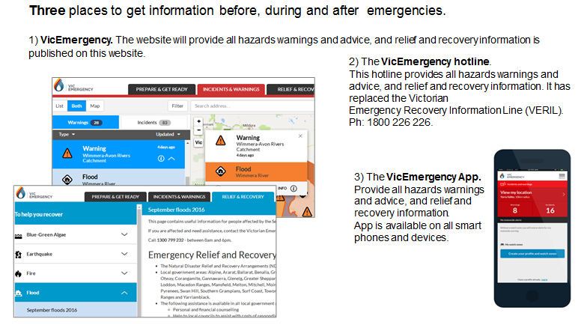

## Part Five - Prevention and Preparedness

Any information released to the public on behalf of Latrobe City will be to inform and assist the community to prepare for emergencies. This information must be approved by Latrobe City’s Chief Executive Officer (CEO)

## Part Six - Response Phase

Releasing information is normally the responsibility of the incident Controller in conjunction with the Control Agency(s). General information released by the Municipality must be approved by the CEO

Information can be categorised under the following headings:

Pre impact

To enable the public to take reasonable measures to prevent, or lessen the potential effects of emergencies and to cope during the impact phase of an emergency.

During impact

To produce suitable news releases through the media concerning the effects of the emergency and what action can be taken by the public, these need to be implemented with such information is subject to release approval from the Incident Controller or his/her delegate.

Post impact

To maintain the crucial information flow to those in need of assistance and direction.

It is important that there is continuity of emergency management structures and arrangements to ensure support for impacted communities. Integration of relief and recovery within the IMT supports this. This is also support by JSOP 4.01 – which requires relief and recovery messaging to be integrated with response information.

Public Information Officers are now responsible for development of a communications plan to ensure transition of all public information functions to recovery and handover to the recovery coordinator.

This also helps to support seamless approach and continuity of information to community.

## Part Seven – Relief and Recovery Process

Releasing information will be the responsibility of Latrobe City in conjunction with the Department of Health and Human Services in accordance with Councils Communications sub plan.

Relief reporting and communication requirements are identified on page 24 of the Gippsland Emergency Relief Centre Standard Operating Procedures.

Recovery information and communication management strategies are needed to provide timely, effective communication channels to gather, process and disseminate information relevant to the recovery of the affected community. Council views communication as a joint activity undertaken in partnership with community leaders. The management task is to identify what needs to be communicated, by whom, to whom and when, and how to inform information gathering and analysis processes and the development of reliable and respected dissemination channels.

The information that needs to be communicated in the recovery process depends upon the characteristics of the event in terms of type, location, severity and effects on the community. Activities can include information services to the affected community such as public meetings, newsletters, advertising and dissemination through local community processes such as notice boards or handout material at local shops and businesses.

The broad categories of information that need to be communicated in the recovery process are:

* What has happened in the community;
* What recovery is likely to involve;
* What plans are in place for the well-being of the community;
* What services and resources are available for recovery of the community and how to access them;
* Information which will assist the community to effect recovery; and
* Who has responsibility for the various elements of recovery.

It is also important that messages acknowledge the sense of grief and loss in the community, but are also balanced, at the appropriate time and way, with creating a sense of optimism about their future.

The means of communicating information to the affected community, recovery workers, elected representatives and the media differ vastly. It also should be kept clearly in mind that all four groups are disseminators of information as well as receivers.

The Council Communications Unit will provide support to the various committees including the Municipal Recovery Sub-committee, including assistance with the preparation of communication material; coordination of communication activities; liaison with communication units of other stakeholders; and media engagement and liaison.

Council may appoint authorised officers and elected members as media spokespersons. A guide to officer and councillor media roles is provided in the two Guides produced by the Municipal Association of Victoria and EMV:

* A Guide to the Role of Mayors and Councillors in Emergency Management
* A Guide to the Role of the Council Chief Executive Officer in Emergency Management
* EM Cop has a bank of relief and recovery information on a range of emergencies, it should be used and shared with Councils Pre-approved Agency and Department relief and recovery communications can be found here.

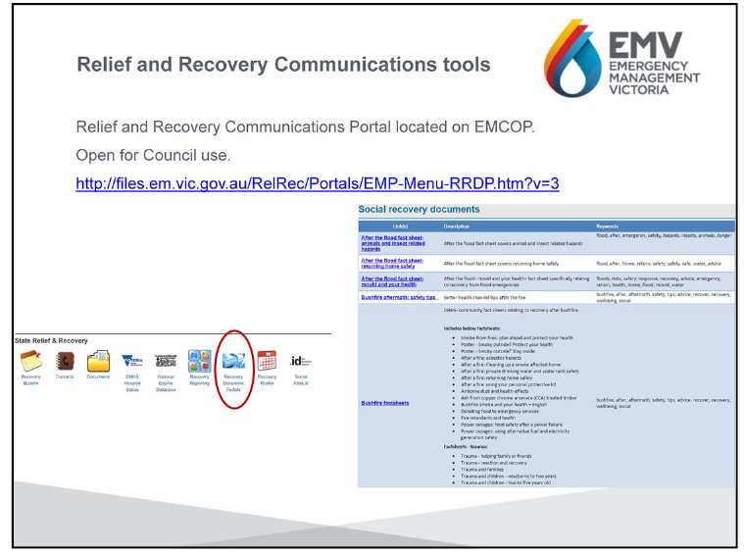

### 7.1 Information Management Principles

The principles of effective recovery information management are based on the premise that an affected community has a right to all information relevant to its recovery. The capacity of the community to participate in its own recovery is directly dependent on communication of information. In summary:

* Information is the right of an affected community
* Information enhances the capacity of an affected community to manage its own recovery
* Information should be timely, factual and disseminated through a range of communication channels and through a range of methods. In the case of events affecting people from non-English speaking backgrounds, this includes provision of information through a range of ethnic media and in appropriate languages
* Information should be repeated frequently in the early stages following an event, and
* Information needs change during the course of the recovery.

### 7.2 Community Engagement and Communication Strategy

A crucial element of this Plan is to ensure there are practices in place that keep all stakeholders informed, involved and active in support of affected communities. Latrobe City is committed to implementing the principles that underlie good community engagement practices. As outlined in Latrobe City’s current Community Engagement Policy and Strategy these community engagement principles are:

* Participation – inclusiveness, accessibility and diversity
* Focus
* Provision of Information
* Timing
* Responsiveness and Feedback
* Evaluation

### 7.3 Community Briefings

Community briefings may be conducted by response agencies as part of their role in keeping communities aware of the current emergency situation before, during and after events. Recovery managers are a key part of the process and briefing teams.

As soon as practicable after an emergency the Latrobe City Municipal Recovery Manager, in partnership with community leaders, will arrange community information sessions as part of its Community Communication Plan. The development of these sessions is the first practical step in the process of ensuring a community is actively involved in the recovery management process. These sessions can also be used to support the development of Community Recovery Committees and in identifying key needs and issues to be addressed

The role of community briefings in the recovery context is to provide:

* Clarification of the emergency event (Control agency).
* Advice on services available (Recovery agencies).
* Input into the development of management strategies (Council).
* Advice to affected individuals on how to manage their own recovery, including
* Preventative health information (Specialist advisers) and receive information on current and emerging needs.

Where the emergency has a criminal component or involves a coronial enquiry, then Latrobe City will ask the responsible authority to deliver key messages. Local agreements with response agencies that have responsibility for community briefings will be developed as part of Municipal Emergency Management Plans.

### 7.4 Development and Use of Community Networks

Existing community networks are a valuable conduit for information delivery, needs identification and support of those affected. These established networks are significant in the community and have an inherent value.

Where possible and appropriate, recovery programs will work with and through these networks. Community networks that are established, legitimate and functioning in an affected community will be actively engaged and supported in the recovery process. In some instances networks may be present in the community but require additional support to enable them to function more effectively as a recovery conduit to the community.

Examples of community networks may include:

* Township associations, progress associations or hall committees and other community committees
* Volunteer emergency services
* Church organisations
* School organisations
* Ethnic social groups
* Service clubs
* Service providers
* Landcare groups
* Sporting associations and recreational clubs

## 

## Part Eight - Information Management

One of the key elements of emergency relief and recovery is effective information management. The media profile given to most emergencies, particularly those on a large scale, means that public and political interest in the recovery process will generally be high. Added to this is the need for adequate information to be provided to affected communities and individuals regarding the effects of the event and the availability of recovery services?

With one of the underlying principles of recovery management being the empowerment of individuals and communities to participate in the management of their own recovery, it is critical that regular and accurate information be provided regarding such things as the cause and effects of the emergency, the type and availability of recovery services and any other relevant information. This information should be made available in as many languages as necessary to meet the needs of people affected by the event from CALD backgrounds. This will enhance the capacity of the community to participate in the management of their own recovery.

There are is range of mechanisms for providing information to the public. These may include local newsletters, press releases, use of the various electronic media and public meetings or forums.

Given the media, political and public profile of emergencies there will also be a need for the provision of up-to-date, accurate information regarding recovery services and advice on the state of the affected community to a range of sources. This need will be particularly prevalent in the early stages of the recovery process, the time at which recovery managers will be under most pressure. Consequently, it is important that effective information management systems be established as soon as possible following an emergency. Ideally systems and protocols for the dissemination of information should have been developed as part of the recovery planning process and should only require minor adjustments to maximise the flow of information after an emergency has occurred.

## Part Nine - Media

During disasters the press, radio, and television have a legitimate interest in obtaining prompt and accurate information. If media access to accurate information is unduly restricted, rumour and speculation may be substituted for fact.

Due to the fact that the recovery process will generally involve a range of different organisations there is a need for coordination of information to the media to avoid confusion or conflicting messages. The most effective means of dealing with this issue is through the nomination of a media liaison officer to represent the overall recovery process.

Where appropriate Latrobe City will appoint a media liaison officer to oversee and manage councils media coordination.

## Part Ten - Dissemination

Immediate use of the media will be made to avoid phone congestion. The public should be advised to direct calls to appropriate agencies and centres with adequate facilities, staff and knowledge to answer questions or disseminate information:- For example, the VicEmergency Hotline (VBIL), Police "Advice Line" should be used if appropriate.

The "Standard Emergency Warning Signal" may be used to alert the public to an actual or impending emergency or maintain the dissemination of public information. Authority to use the signal over electronic media must be given by the Regional Emergency Response Coordinator or his/her representative.

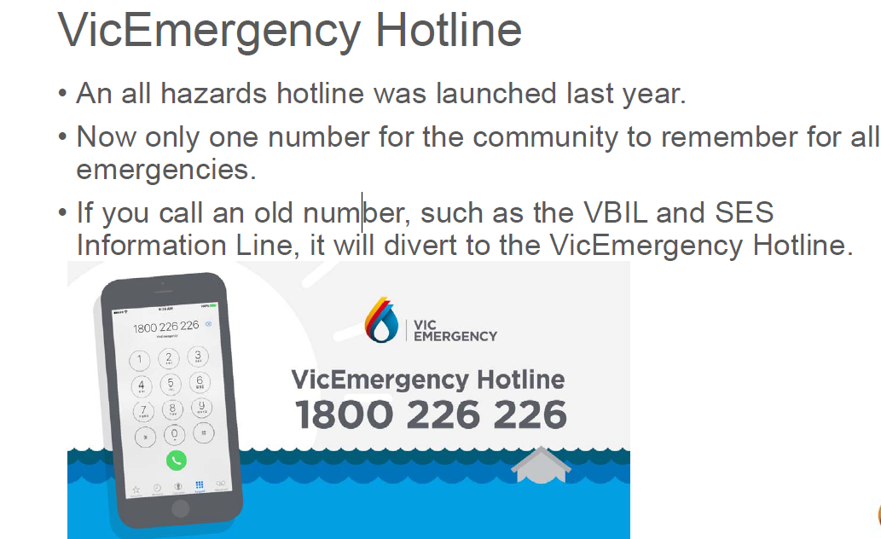

## 

## Part Eleven - Communication Methods

Internal council communications shall be via the Latrobe City CEO as advised by the MERO/MRM through councils internal communication systems.

##### External

All methods of disseminating information will be considered including:

* Radio Stations, both ABC Gippsland and local commercial
* Television
* SMS
* Social media (eg Twitter, Facebook and Youtube, etc).
* Vic Emergency Hotline
* Police Advice Line
* Local Telephone Information Lines
* Newspapers (particularly in extended response and recovery phases)
* Ethnic group’s radio stations and newspapers
* Community Newsletters
* Information Centres (“One Stop Shops”)
* Manual door knock of each residence
* Letter drop
* Public address system mounted on vehicle

##### Disabled or CALD Persons

Special considerations need to be given to warning disabled and CALD groups. In the case where information or communication is required with persons unable to speak English an interpreter service such as the Telephone Interpreter Service may be able to assist.

All agency representatives dealing with this situation should carry a language indicator card which can be used to establish the language in question. Copies of this card are available from the Commonwealth Department of Immigration and Citizenship and Latrobe City Citizen Service Centres.

The telephone number for the Telephone Interpreter Service is **131 450**

## Part Twelve- Information Resources

The following systems are an essential part of these arrangements and will be utilised if and when required:

* Electronic Media (including Latrobe City Web Site)
* Police Media Liaison
* Literature/Brochure Information
* Print Media

If an emergency requires concurrent media response through radio, television and newspaper outlets, the Police Media Liaison Section may be contacted through the Municipal Emergency Response Coordinator.

##### Public Information Centre

If required, a public and media information centre will be established. Latrobe City shall appoint a Media Liaison Officer.

## Part Thirteen - Warning Systems

The following should be considerations when anticipating the use of warning systems:

* The type of emergency
* The number of people affected
* The cultural and linguistic origins of the affected people
* The requirements of any Special Needs Groups

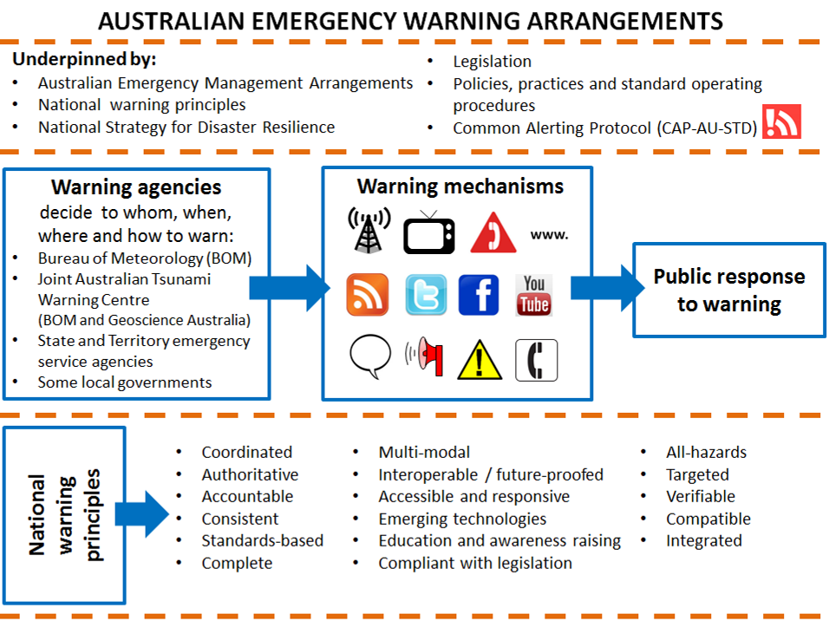

Commonwealth and state and territory warning authorities have a suite of delivery mechanisms to issue warnings to the community about actual or impending emergencies. These range from traditional methods such as television and radio broadcasts, community meetings and sirens, to more modern methods, such as mobile telephone SMS messages and social networking posts (eg. Facebook and Twitter).

All Australian governments support a multi-modal approach to issuing emergency warnings. A multimodal approach maximises the likelihood that as many people as possible will receive and comprehend a warning. This makes it more likely that people will be in a position to take appropriate action to protect against loss of life, or injury, and to mitigate against damage to property.

No warning mechanism is guaranteed to deliver warnings to all people in a given area at a given point in time. Thus, it is critical that no single mode of warning or communication is relied upon solely, in times of emergency—either by the public to receive warnings, or by warning agencies to disseminate them.

##### The Standard Emergency Warning Signal

The [Standard Emergency Warning Signal](http://www.em.gov.au/Emergency-Warnings/Pages/StandardEmergencyWarningSignalSEWS.aspx) (SEWS) is a distinctive audio signal used in Australia to alert the public to the broadcast of an urgent safety message relating to a major disaster or emergency. It is meant to attract listener’s attention to an impending emergency message. For example, Emergency Alert warnings sent to landline telephones commence with the SEWS signal.

In addition to the audio signal, SEWS also has a visual identity which includes a logo and slogan for use by the media. The visual identity facilitates greater awareness of SEWS



**Emergency warning mechanisms used by Emergency**

**Services organisations in Australia.**

The following table provides an explanation of the types of warning mechanisms available.

|  |  |
| --- | --- |
| **Broadcast radio** | Broadcast radio, particularly local radio, can play a significant role in disseminating timely, tailored and relevant warnings and information to communities at risk of an emergency. |
| **Television** | Similar to radio, television can provide timely and useful information to the public in the event of an emergency. Television has the advantage of being able to provide captioning for people who are Deaf or hearing impaired, and some television media outlets also provide an Auslan interpretor during a disaster. |
| **Emergency Alert** | Emergency Alert is Australia’s nationally consistent telephone-based emergency warning system. It is a 24/7 intrusive capability which issues warnings to telephones linked to the addresses (properties and houses) within a geographical area affected by an emergency. Emergency Alert warnings can now also be sent to some mobile telephones based on the last known location of the handset at the time of an emergency. Location-based warnings will be available on all mobile networks from November 2013. See [www.emergencyalert.gov.au](http://www.emergencyalert.gov.au). |
| **Official emergency services website** | Many official emergency services websites provide up-to-date emergency warnings and information for the public. |
| telephone-hi**Emergency services information line and IVR** | A number of emergency services organisations provide warnings and hazard information to the public via telephone information lines and interactive voice recordings (IVR). |
| **RSS Feed** | RSS feeds allow the public to receive live web feeds from official emergency services websites to keep up to date on emergency information. |
| speechbubble1**Face-to-face** | Face-to-face meetings between emergency services and individuals, including door‑knocking, and community or street meetings, is used in some circumstances to issue localised emergency warnings from emergency services personnel to members of the public. |
| **Twitter** | Social media sites such as Twitter, Facebook and YouTube are now recognised by many emergency services organisations as important tools for communicating with people during emergencies, and can also be an important source for situational intelligence. |
| **Facebook** |
| **YouTube** |
| **Hazard signs** | Hazard signs, including electronic signs, are used to warn the public of dangerous conditions. |
| **Community sirens** | A community siren is a mechanical or electronic device used for generating either a loud signal or a voice message to warn a community that an emergency has been identified in the local area and that people should seek further information. |

State and Territory warning originators

The following agencies have a role in providing emergency warnings to the community. Most agencies issue warnings via face-to-face meetings, door-knocking, radio, television, Emergency Alert and official websites. Increasingly, agencies are adopting social media, such as RSS, Facebook and Twitter to issue warnings to a wider audience.

Further information on the types of warnings issued by each agency can be found by contacting the agency directly.

## 

## Part Fourteen - Emergency Communication Systems

##### From FIELD LEVEL RESPONSE - to - AGENCY CONTROL POINTS

Depending in the type of emergency, communications will come from any or a combination of:

* Landline telephone
* Mobile phone
* Satellite telephone
* Portable 2-way radio (High, Very High, Ultra High frequency)
* Vehicle to Base portable radio
* Facsimile Machine
* Crisisworks
* Other electronic media/social media
* Email

##### From FIELD LEVEL RESPONSE by LATROBE CITY STAFF to MECC/MCC/MERO/MRM and MERC

* Mobile phone
* Portable 2-way radio
* Direct Communications
* Email
* SMS
* Crisisworks

**From MUNICIPAL LEVEL (MECC's, EMLOS) - to - FIELD CO-ORDINATORS, CONTROL AGENCIES, SUPPORT AGENCIES, POLICE 000 ,REGIONAL EMERG/RESPONSE/CO-ORD/CENTRES.**

* Telephone lines
* Mobile phones
* Facsimile
* Portable radios
* Computer data links
* Satellite telephones
* SMS
* Crisisworks
* Other electronic media/social media
* Email

**From REGIONAL LEVEL (RERC's) - to. - STATE EMERG/RESP/CO-ORD/CENTRE, CONTROL AGENCIES AT REGIONAL HQ's, POLICE 000, SUPPORT AGENCIES**

* Telephone Line and Mobile.
* Computer Data Link
* Facsimile
* Email
* Identified Communications Black Spot Locations

Part Fifteen - Geographic

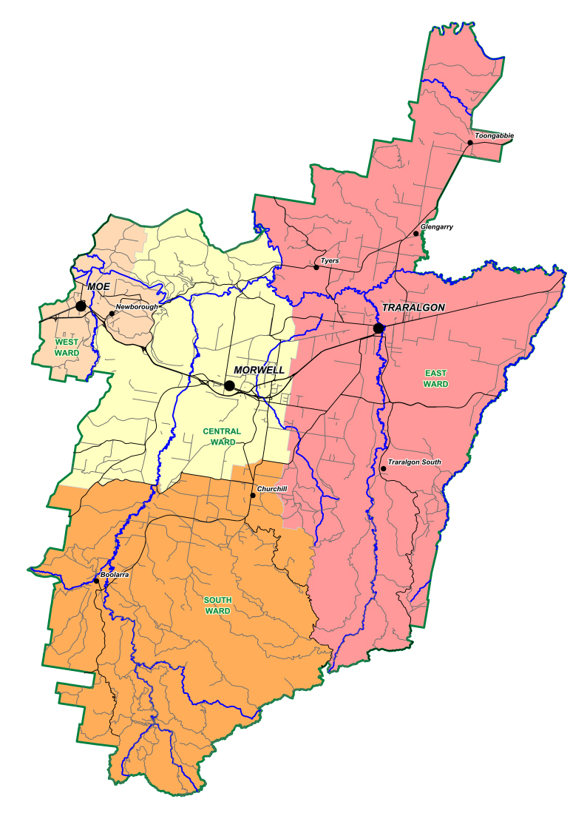

## Part Sixteen - MECC Communications

Lines of Communication - From Control Points to MECC Traralgon (all agencies)

Designated phone numbers exist for each EMLO

Dependant on the requirements of the MECC other numbers will be allocated as required.

Network Connection Points - 4

## Part Seventeen - MECC Internal and External Communications

All communications will be recorded on Crisisworks.

Crisisworks

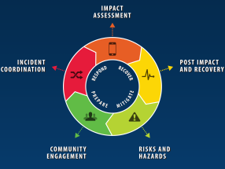

The use of Crisisworks is integral in the operation of Latrobe City MECC’s by giving council staff and agency personal access to enable 24/7 seamless coordination.

The Crisisworks system is a cloud based web tool that enhances the paper based MAV MECC practice note. It also allows us to store emergency management plans, contact lists, sub plans, or any other relevant document to be accessed by staff and agency personal in a secure manner.

Latrobe City uses Crisisworks to facilitate enhanced coordination, communication, situational awareness and community engagement across all phases of its emergency management activations.

We use Crisisworks to coordinate our incident response, log requests and actions, assign activities, deploy resources and get real-time updates. Access via status boards and maps for a common operating picture, whether in our MECC or in the field is also a key feature.

The system is used to capture information and intelligence and report on disaster damage within minutes via mobile devices. It enables staff to conduct impact assessments, quickly generate reports and share data on economic impact to property, infrastructure, environmental and social impacts

We can register people and assets impacted during an emergency and track potential hazards with secure and confidential intelligence capture and reporting through this system.

For Access to Crisisworks please contact one of the following people -

**Latrobe City’s Coordinator Emergency Management or Emergency Management Support Officer**.



Telephone Directory - All relevant contact numbers for this plan are in Crisisworks and attached to this plan. Current directories are supplied.

* Back-Up Communication Systems
* WICEN via contacting MERC/MERO.
* Portable Radio pool via MERC.
* CB Radios via MERO.

## Part Eighteen - Latrobe City Internal Emergency Communications Procedure

Upon notification of an emergency impact within the municipality or neighbouring municipality requiring Council support to assist the community and/or response agencies, the Latrobe City Coordinator Emergency Management will:

* Notify Latrobe City Council’s Chief Executive Officer
* Notify General Manager Community Liveability
* Notify Latrobe City MRM
* Notify the appropriate Latrobe City MERC by ringing 000
* Notify Latrobe City Coordinator Communications
* Put on standby appropriate staff for preparation, relief, response and recovery
* Notify neighbouring municipalities to be put on standby as per our emergency relief arrangements and the MAV resource sharing protocols.

Latrobe City CEO or delegate will, depending on the impact, notify Latrobe City Councillors of any such emergency event directly affecting the Municipality. Any information released to the public on behalf of Latrobe City will be to educate and assist the community to prepare for emergencies. This information must be approved by Latrobe City’s Chief Executive Officer (CEO).

Latrobe City’s Coordinator Communications will liaise with Latrobe City’s MERO and MRM in relation to all media information relating to the emergency impacts as released by the Incident Controller to staff and the community.

Staff Information

The MERO will notify all staff of any emergency impact via an “Allstaff” email, on approval by the General Manager Community Liveability. If the General Manager Community Liveability is unavailable the MERO has delegated authority from the CEO to forward this information on.

Latrobe City Managers and Coordinators are responsible for forwarding this information to all off-site staff across the Municipality.

During all phases of the emergency the MERO/MRM will keep Latrobe City Coordinator Communications informed of all information relevant to the emergency where appropriate.

## Part Nineteen - Appendix:

##### Latrobe City Emergency Contact Directory

Not for Public Use

##### Agency SMR Trunk Radio Numbers

Not for public Use