Morwell RSL
Women’s Auxiliary High Tea
10th September 2022
2.30pm till 4.00pm
Petite cakes including: 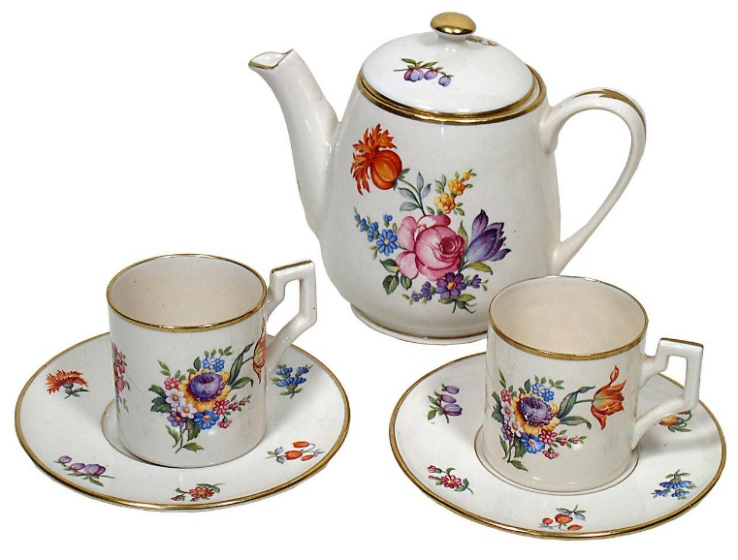
Mini profiteroles Rum balls
Lemon tarts Caramel slice
Mini cupcakes Choc brownies
Savoury:
Assorted pinwheel sandwiches
Mini quiches
Mini sausage rolls
Scones with jam and cream
Tea and Coffee provided

Bookings essential for catering tickets available at the bar.
Venue: ANZAC ROOM Cost: $35.00 per person

